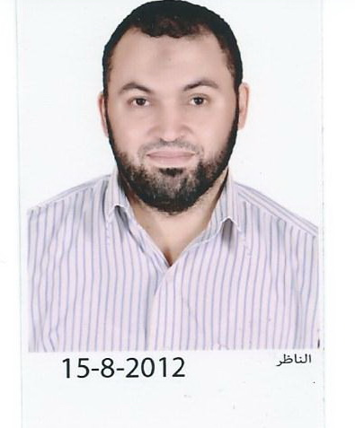

Assiut University Hospital

CURRICULUM VITAE
Abdallah Metwally Abdelzaher Metwally
Personal data | First name :Abdallah  Middle names :Metwally  Last name (Family or Surname): Metwally  Tel: Hospital : +2 088 2414165  Mobile : +2 01005363859  Email :abdallahmetwally71@yahoo.com  Date of birth :14th.April.1971  Marital status : married.  Nationality : Egyptian.  Address : Egypt, Assiut university hospital, department of Ear. Nose. Throut.(Phoniatric uint)  Current hospital: Department of of Ear. Nose. Throut.(Phoniatric uint)  , Assiut University Hospital, Assiut, Egypt.  Non-medical interests: Sports (football)  Languages : Arabic and English.
Current position | Assistant lecturer of Ear. Nose. Throut.(Phoniatric uint)  , Assiut University Hospital, Assiut, Egypt (1/3/2003 till now).
Positions held | House officer: Assiut University Hospital (1/3/1996-28/2/1997).  Resident E. N. T.: Assiut University Hospital (1/31997-28/2/2001).
Qualifications | High school diploma (basic education):Dairot Military high School, dairot,Assuit, Egypt (1986-1989).  MB.Bch: Faculty of medicine, Assiut University (9/1989-9/1995) (very good). [1]  M.Sc. in E. N. T.: Assiut University Hospital (1/3/1997-28/2/2001). [2]
Professional licensure | Egyptian ministry of health full registration no.: 121503-1997/3/2
Clinical Experience | During my work as a house officer, as a resident and as an assistant lecturer, I gained experience in the following activities:  - management practice for most branches of E. N. T.  Operation of tonsselctomy,adenoidectomy  Septal operation  Some ear operation  other
Graduate, post graduate training, courses and conferences attended | 1989-1995: Graduate studies; Faculty of medicine, Assiut University.  1996-1997: House officer; Assiut University Hospital.  1997-2001: Resident E. N. T.., Assiut University Hospital.  .
Teaching activities | Supervising house officers since March,1997.  Supervising the work of residents since March, 2003.  Involved in undergraduate student teaching since March, 2003.
Research activities | Post-tonsselectomy pain management by reduction of tonssilar fossa.(thesis)
Referees and references | [1] Assiut University was inaugurated in 1957 to encourage research, education and community services in Upper Egypt. It is located in Assiut City which is 375 Km south of Cairo, the capital. The university comprises sixteen faculties and two higher institutions. PO Code No. 71515, Egypt. http://www.aun.edu.eg  [2] Assiut University Hospital is one of the biggest University Hospitals in Egypt. It is the core referral center for the whole Upper Egypt that serves about twenty million people. The hospital contains 2027 beds, including 94 ICU beds, and 46 operative theaters in which 240 operations are performed daily. 1478 medical and 6428 paramedical staff serve in this hospital. 3000 patients visit the outpatient clinics and 1000 are received in the emergency departments daily. http://www.aun.edu.eg/fac_med/medicin/Hospital2.htm

